Project Interim Report
On
Courier Delivery Tracking System
(Using Core Java & OOP Concepts)
RU-100-01-00012
Object Oriented Programming With Java
SESSION: 2025-26
Submitted By
Student Name
Ashish Kumar Tiwari
ERP No.- 10309
Bachelor of Technology in Computer Science &
Engineering with AI and ML in association with IBM
Under the Guidance of
Mr. Shivansh Mehta
SCHOOL OF COMPUTER SCIENCE AND ENGINEERING
RUNGTA INTERNATIONAL SKILLS UNIVERSITY
BHILAI, CG
(April 2026)

S. No. | Contents | Page No.
1 | Abstract | 03
2 | Introduction | 04
3 | Objectives | 05
4 | Scope | 06
5 | System Requirements | 07
6 | Methodology | 08
7 | Flowchart | 09
8 | Class Diagram | 10
9 | Implementation | 11
10 | Sample Input / Output | 12
11 | Future Enhancements | 13
12 | Gantt Chart | 14
13 | Conclusion | 15
14 | References | 16

Abstract
The Courier Delivery Tracking System is a Java-based console application that simulates a real-world courier and logistics service using Object-Oriented Programming (OOP) concepts. The system is designed to manage parcels from the moment they are dispatched until they are finally delivered, allowing a user to track the current status of any parcel using a unique tracking ID.
This project demonstrates core OOP principles including encapsulation, class design, and collection handling. A Parcel class encapsulates parcel details such as the parcel ID and delivery status using private fields, with a constructor that initializes the parcel with a default status of “Dispatched.” The updateStatus() method allows the status to move through Dispatched, In Transit, Out for Delivery, and Delivered as the parcel progresses through the logistics chain.
The system is built entirely in Core Java using an ArrayList to store and search multiple parcel records, without requiring any external libraries or database setup. This makes it lightweight, easy to run on any standard Java-enabled machine, and well suited as a learning project for understanding class design, searching logic, and conditional status handling in a real-world inspired scenario.

Introduction
Courier and logistics companies handle thousands of parcels every day, and customers increasingly expect to track their shipments in real time. The Courier Delivery Tracking System is a simplified simulation of such a service, built to demonstrate how Object-Oriented Programming can be used to model real-world business processes in software.
In this system, every parcel is represented as an object of the Parcel class, carrying its own unique tracking ID and delivery status. Multiple parcels are stored together in a collection, and the system allows a user to search for a specific parcel using its tracking ID and view its current status — Dispatched, In Transit, Out for Delivery, or Delivered.
The project is intentionally kept console-based and dependency-free so that the focus remains on the underlying OOP design: class structure, encapsulation of parcel data, constructors, methods for updating state, and basic searching logic over a collection of objects. This mirrors how larger logistics platforms manage shipment state internally, just at a much smaller and more approachable scale.

Objectives
- To design a parcel tracking system using Java classes.
- To manage and update the delivery status of each parcel.
- To implement reliable parcel tracking using unique tracking IDs.
- To simulate the working of a real-world logistics and courier system.
- To strengthen Object-Oriented Programming and logical problem-solving skills.
- To practise storing and searching through a collection of objects using an ArrayList.

Scope
The scope of this project covers the core functionality required to create, track, and update courier parcels within a single console-based application. It focuses on demonstrating sound OOP design rather than building a full production logistics platform.

In Scope
- Creating parcel objects with a unique tracking ID and an initial status.
- Storing multiple parcels in an ArrayList for the duration of the program's execution.
- Searching for a parcel by its tracking ID.
- Updating a parcel's delivery status as it moves through the courier pipeline.
- Displaying the current status of any tracked parcel to the user.

Out of Scope
- Persistent storage of parcel data using a database or file system (covered under Future Enhancements).
- A graphical user interface (the system is console-based only).
- Integration with real courier APIs, payment systems, or live GPS tracking.
- Multi-user access, authentication, or role-based permissions.

System Requirements

Software Requirements
Requirement | Specification
Programming Language | Java (JDK 8 or above)
IDE | Eclipse, IntelliJ IDEA, or any text editor with javac/java
Operating System | Windows, Linux, or macOS (platform independent)

Hardware Requirements
Requirement | Specification
Processor | Any modern processor (1 GHz or above)
RAM | 1 GB minimum (2 GB or more recommended)
Storage | Minimal disk space (under 50 MB for source and class files)

Methodology
The system is developed step by step, following a clear OOP-driven approach:
- Create a Parcel class that represents a single courier parcel.
- Store parcel details — parcelId and status — as private fields to enforce encapsulation.
- Initialize each parcel through a constructor that sets the tracking ID and a default status of “Dispatched.”
- Implement an updateStatus() method that allows the parcel's status to be changed as it progresses through the courier pipeline.
- Store multiple parcel objects in an ArrayList so that any number of parcels can be tracked at once.
- Allow the user to enter a tracking ID and search the collection for a matching parcel.
- Display the current delivery status of the parcel that matches the entered ID, or a suitable message if no match is found.
- Test the complete flow using a main class (CourierSystem) that creates parcels, updates their statuses, and tracks them by ID.

Flowchart
The flowchart below illustrates the overall control flow of the Courier Delivery Tracking System, from parcel creation to status tracking and updates.
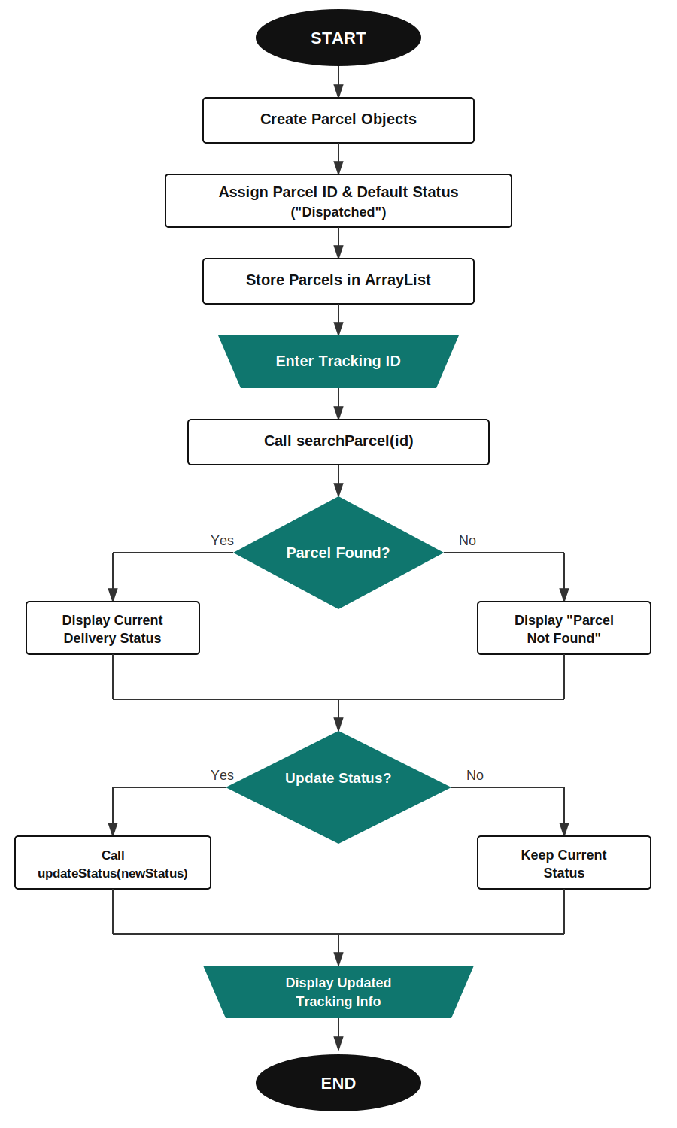

Class Diagram
The class structure below shows the Parcel class and the CourierSystem driver class, along with their key fields and methods.

«class» Parcel
- parcelId: String
- status: String
+ Parcel(parcelId: String)
+ updateStatus(newStatus: String): void
+ getParcelId(): String
+ getStatus(): String

«class» CourierSystem (Driver Class)
- parcelList: ArrayList<Parcel>
+ main(args: String[]): void
+ searchParcel(parcelId: String): Parcel
+ displayStatus(parcel: Parcel): void

Implementation

Parcel.java
The Parcel class is the core data-holding class of the system. It stores two private attributes: parcelId (String) and status (String). The constructor accepts a parcel ID and initializes the status to “Dispatched” by default, since every parcel begins its journey in the dispatched state. The updateStatus(String newStatus) method allows the status field to be changed as the parcel moves through the courier pipeline, and getter methods expose the parcel ID and status to the rest of the program.
Example logic:
private String parcelId;
private String status;

public Parcel(String parcelId) {
this.parcelId = parcelId;
this.status = "Dispatched";
}

public void updateStatus(String newStatus) {
status = newStatus;
}

CourierSystem.java (Driver Class)
The CourierSystem class contains the main() method and drives the entire application. It creates multiple Parcel objects, stores them in an ArrayList, and updates a few statuses to simulate real progress (for example, moving a parcel from “Dispatched” to “In Transit” or “Delivered”). It then prompts the user to enter a tracking ID, loops through the ArrayList to find a matching parcelId, and displays the corresponding status — or an appropriate “not found” message if no parcel matches the entered ID.

Sample Input / Output
The following output is produced when two parcels, P101 and P102, are created and tracked by their IDs:
--- Courier Delivery Tracking System ---

Enter Parcel ID: P101
Status: In Transit

Enter Parcel ID: P102
Status: Delivered

Enter Parcel ID: P105
Parcel not found. Please check the tracking ID.

Future Enhancements
The current system can be extended with the following features for additional learning and real-world relevance:
- Date and time tracking for each status update, to show when a parcel changed state.
- Estimated delivery time calculation based on distance or courier service type.
- File handling to store parcel data persistently between program runs.
- A menu-driven interface for adding, updating, and searching parcels interactively.
- A graphical user interface built using Java Swing for a more user-friendly experience.

Gantt Chart
The following Gantt chart outlines the project timeline across four weeks:
Task | Week 1 | Week 2 | Week 3 | Week 4
Planning & Requirements | ████
Class Design (Parcel) | ████ | ████
Constructor & Encapsulation |  | ████
ArrayList Storage & Search Logic |  | ████ | ████
updateStatus() Implementation |  |  | ████
Main Method & Testing |  |  | ████ | ████
Report Writing |  |  |  | ████
Viva Preparation |  |  |  | ████

Conclusion
The Courier Delivery Tracking System successfully demonstrates how Object-Oriented Programming concepts can be applied to model a real-world logistics process. By encapsulating parcel details inside a dedicated Parcel class and managing a collection of parcels through an ArrayList, the project shows a clean, maintainable approach to tracking the lifecycle of a shipment from dispatch to delivery.
Through this project, key concepts such as classes and objects, encapsulation, constructors, methods, collections, and conditional searching logic were practically applied and reinforced. The system, while simple, mirrors the core logic used by real courier and logistics platforms, providing a strong foundation for further enhancements such as persistent storage, a graphical interface, or integration with real tracking APIs.

References
- Oracle Java Documentation — https://docs.oracle.com/javase/
- GeeksforGeeks — Java OOP Concepts (Classes, Objects, Encapsulation)
- GeeksforGeeks — ArrayList in Java
- Java Tutorials by Oracle — Collections Framework
- Course material and lecture notes on Object-Oriented Programming with Java

